**Project Development**

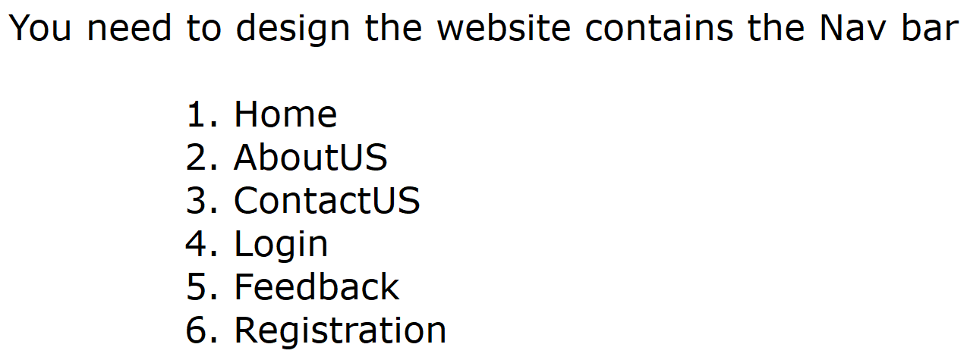

Wire Frame of the Website should be follows as like this

**Landing Page of the Website**

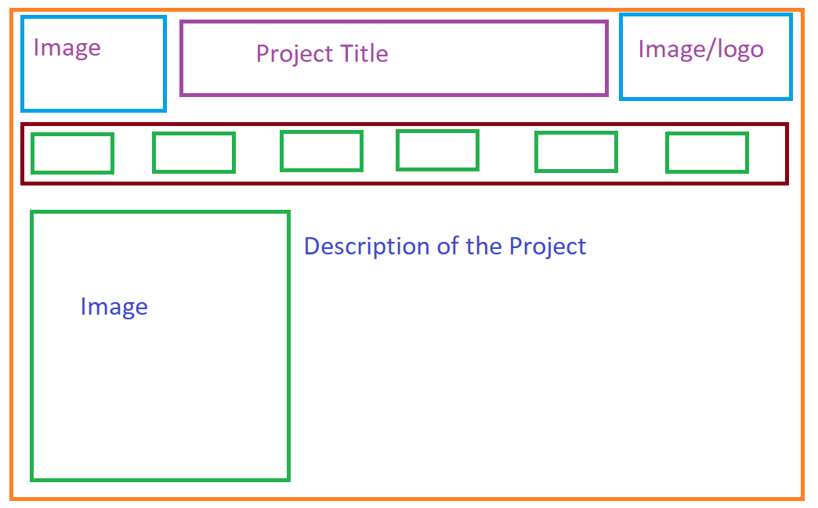

You Need to define the sub pages for each Nav bar item

You should define the Validations for the input fields like EmailID, Mobile Number, Date of Birth, Year of Passout, Joining Year, Branch, Roll Number

When you login aslo, you should validate the Username and Password

When you define feedback, you should validate again the Username, EmailID and Roll Number

**Sample Project List**

1. Hospital Management System
2. College Management System(T & P)
3. Vehicle Management System
4. Hotel Management System
5. SuperMarket Project
6. Bus Reservation System
7. Train Reservation System
8. Airline Reservation System
9. Billing System for Mobile